**End Result of this activity**: The volumecolumn in the last screenshot, we can again see that

the sales growth is more consistent than the original Bat Scooter. The growth

within the first week is less than that of the original model, but it is sustained

over a longer period. After 22 days of sales, the sales growth of the limited-edition

scooter is 65% compared to the previous week, as compared with the 28% growth

identified in the second activity of the chapter.

This shows the launch date for all models

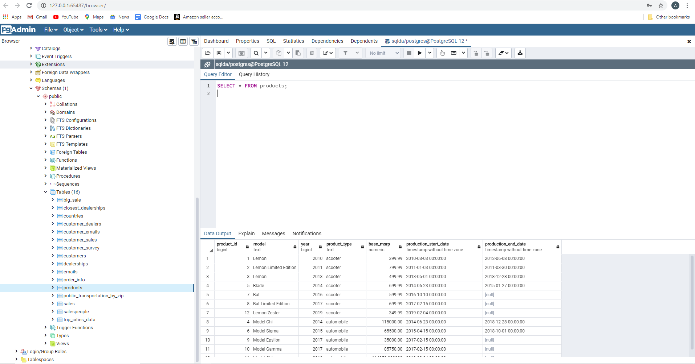

The following screenshot displays the product type=scooter

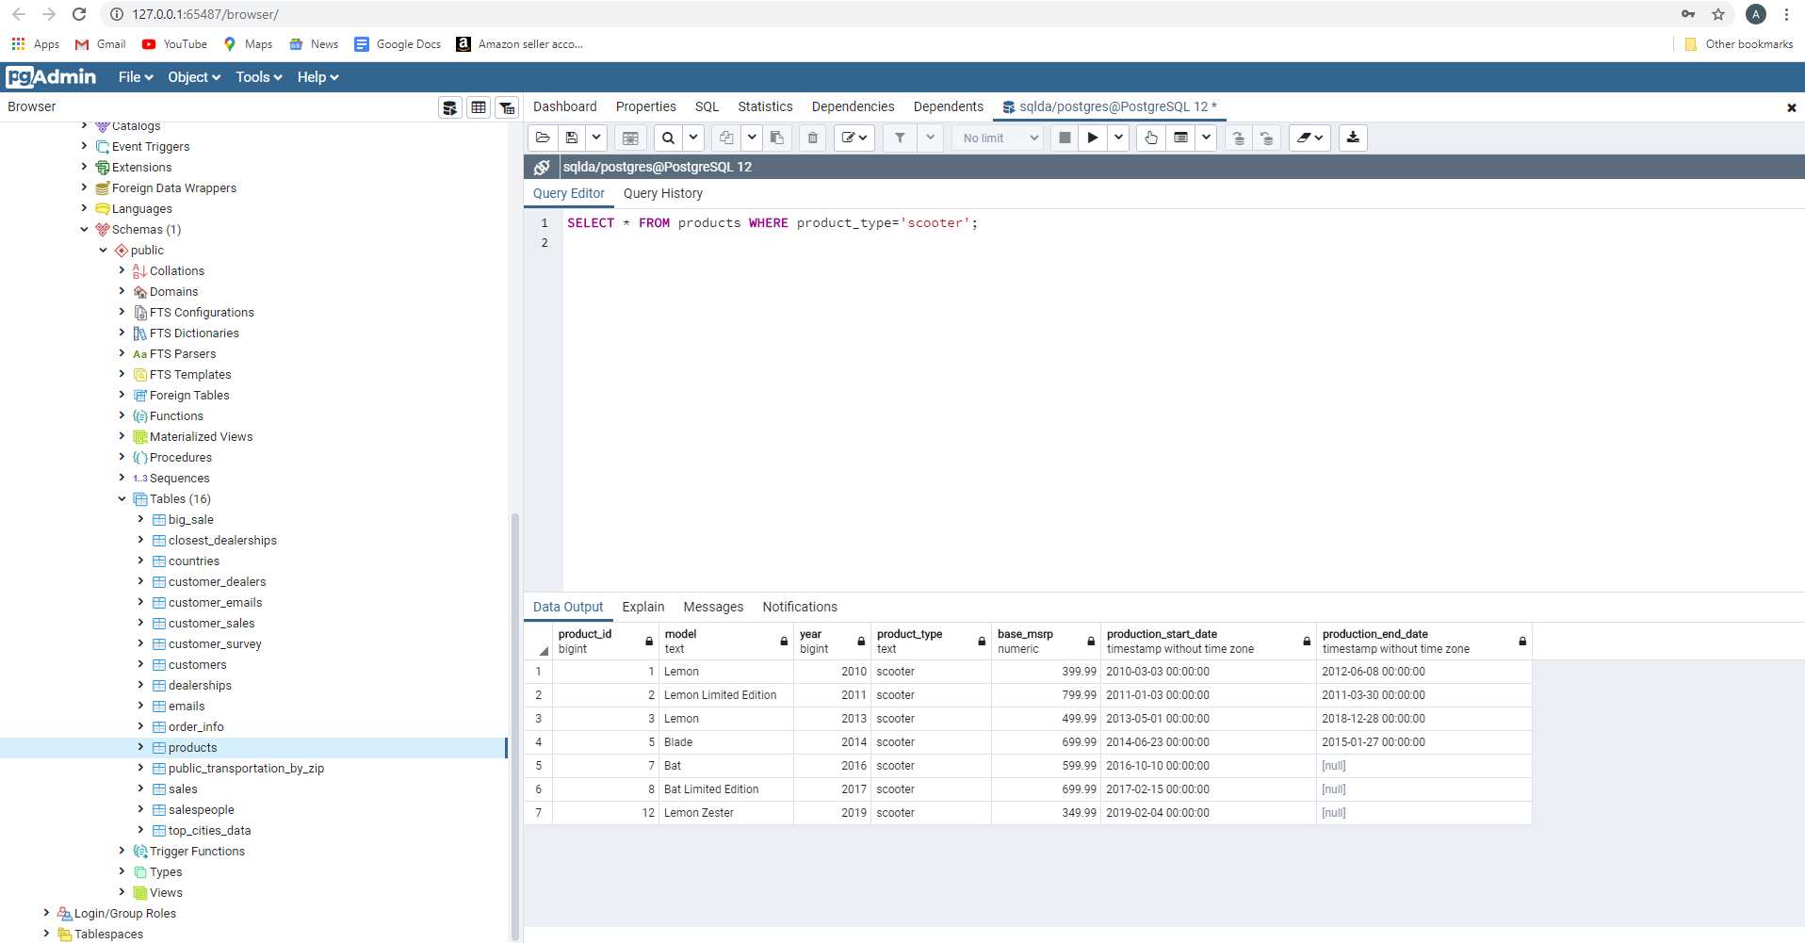

For us, to test the hypothesis of if the time of the year affects the sales performance. We must pick a scooter model at random and carryout the analysis to prove our hypothesis.

This displays the first 5 row of the sales table

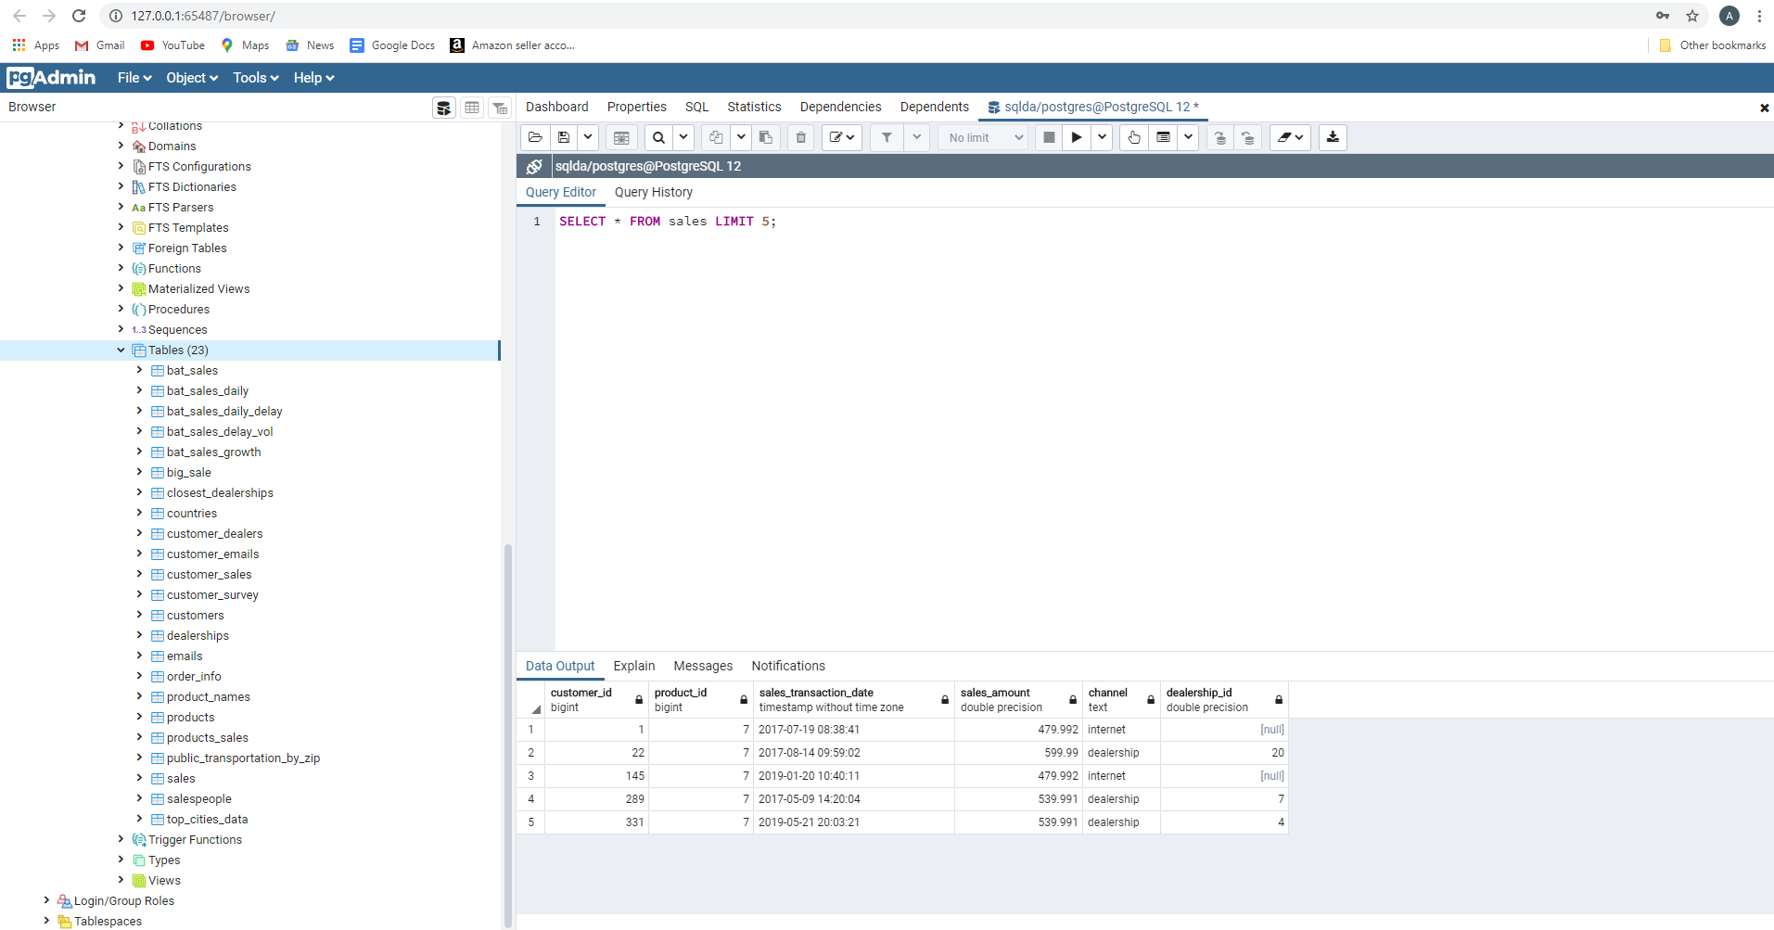

This displays an inner join of the sales and product tables and creating a table bat_ltd_sales

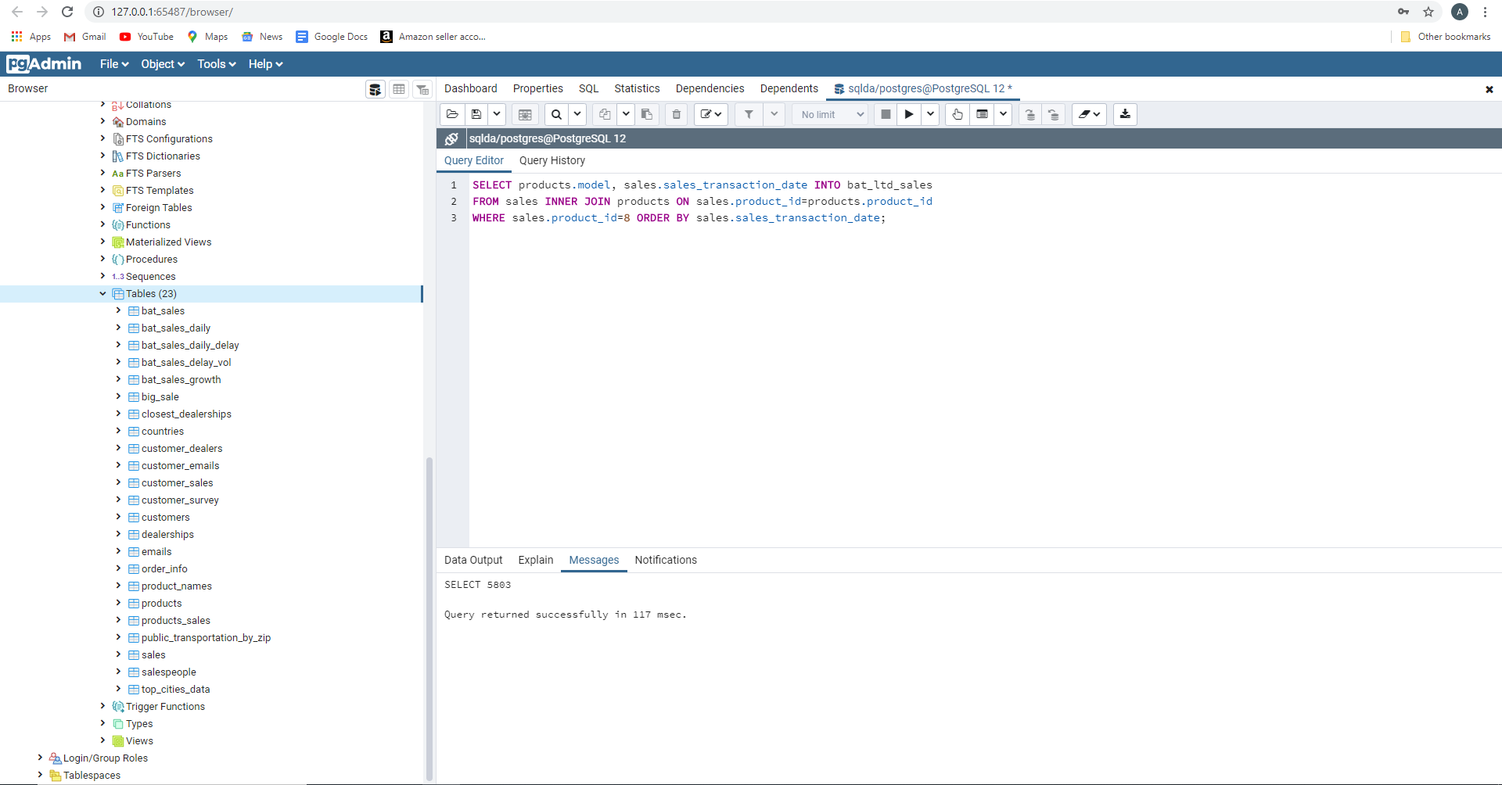

The first 5 records of the bat_ltd_sales table

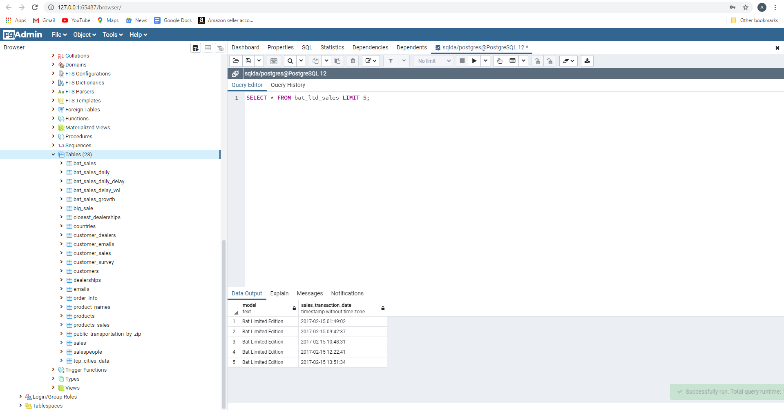

This is compared to the original Bat Scooter, which are 7,328 items sold from exercise 35

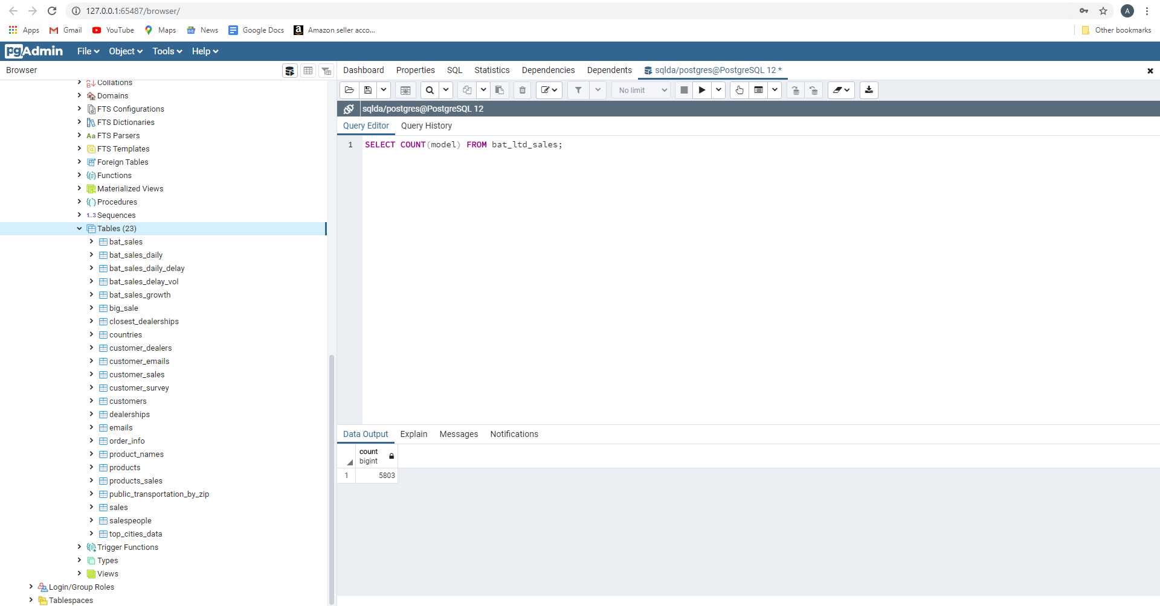

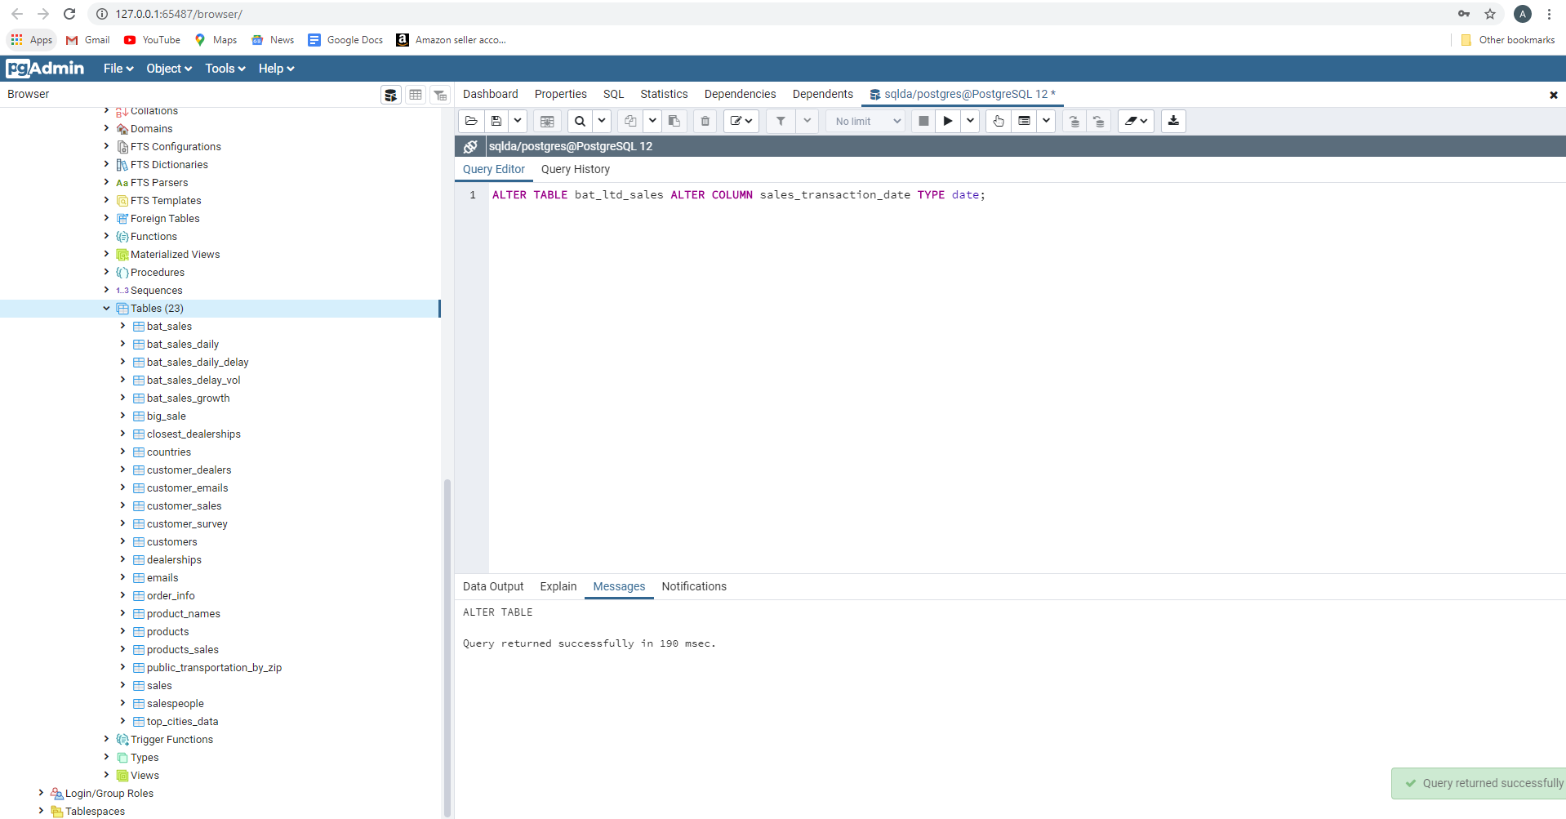

After, the above query of alter table. These are the first 5 records of bat_ltd_sales



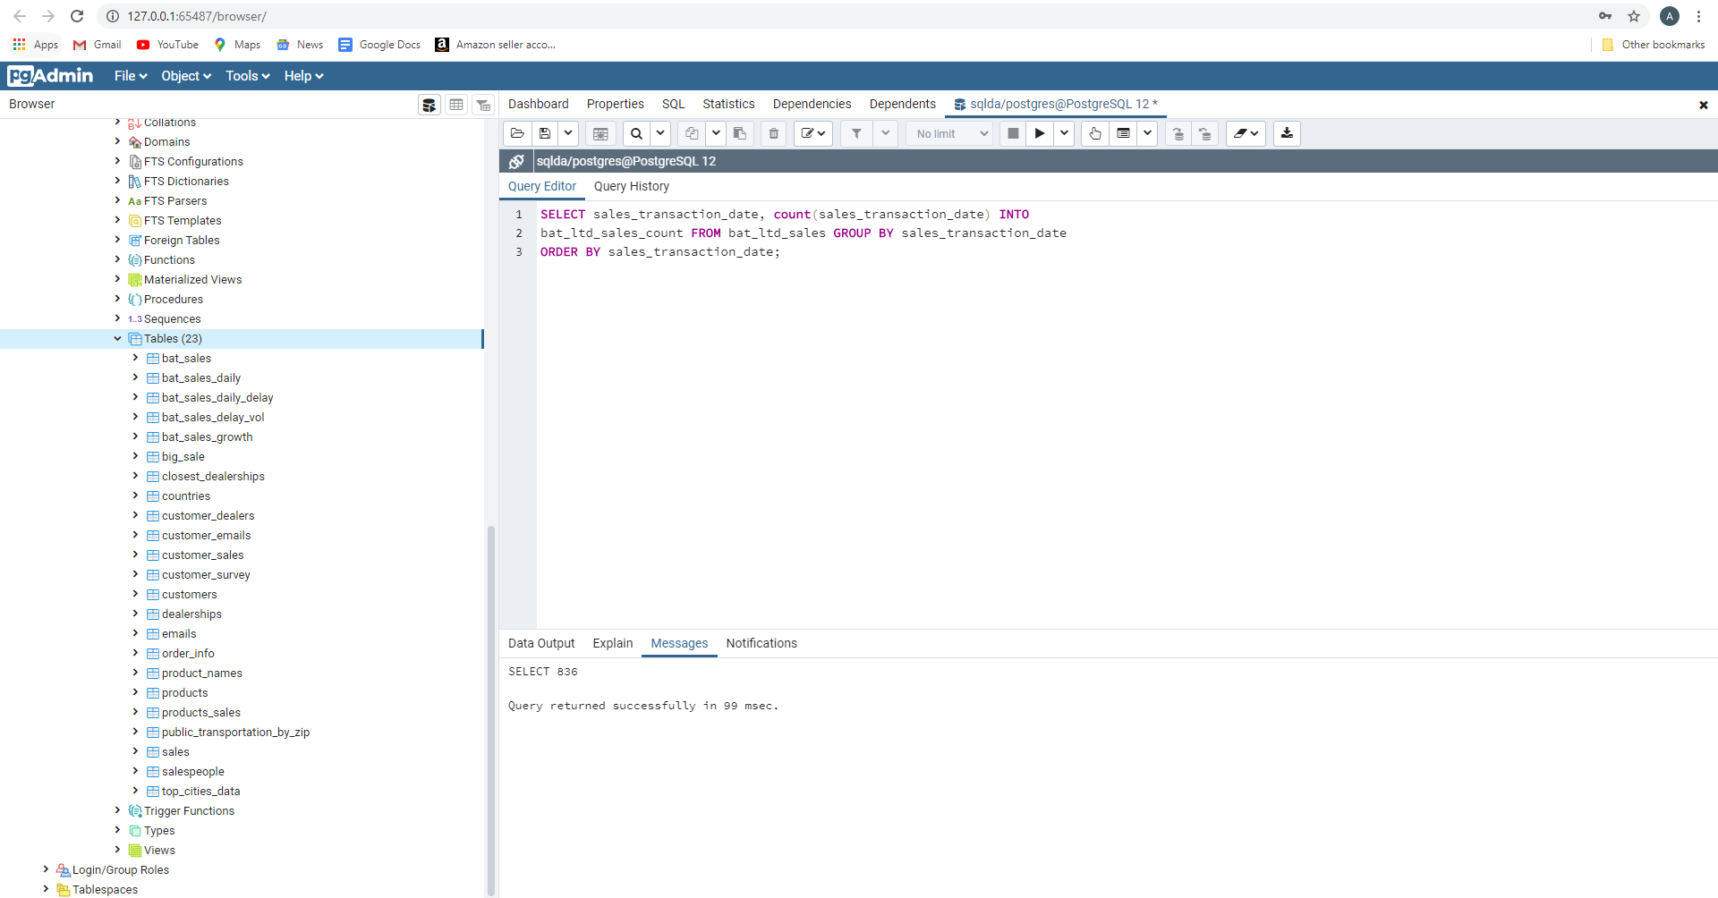

The max sales for bat_ltd_sales is on 31st May 2019

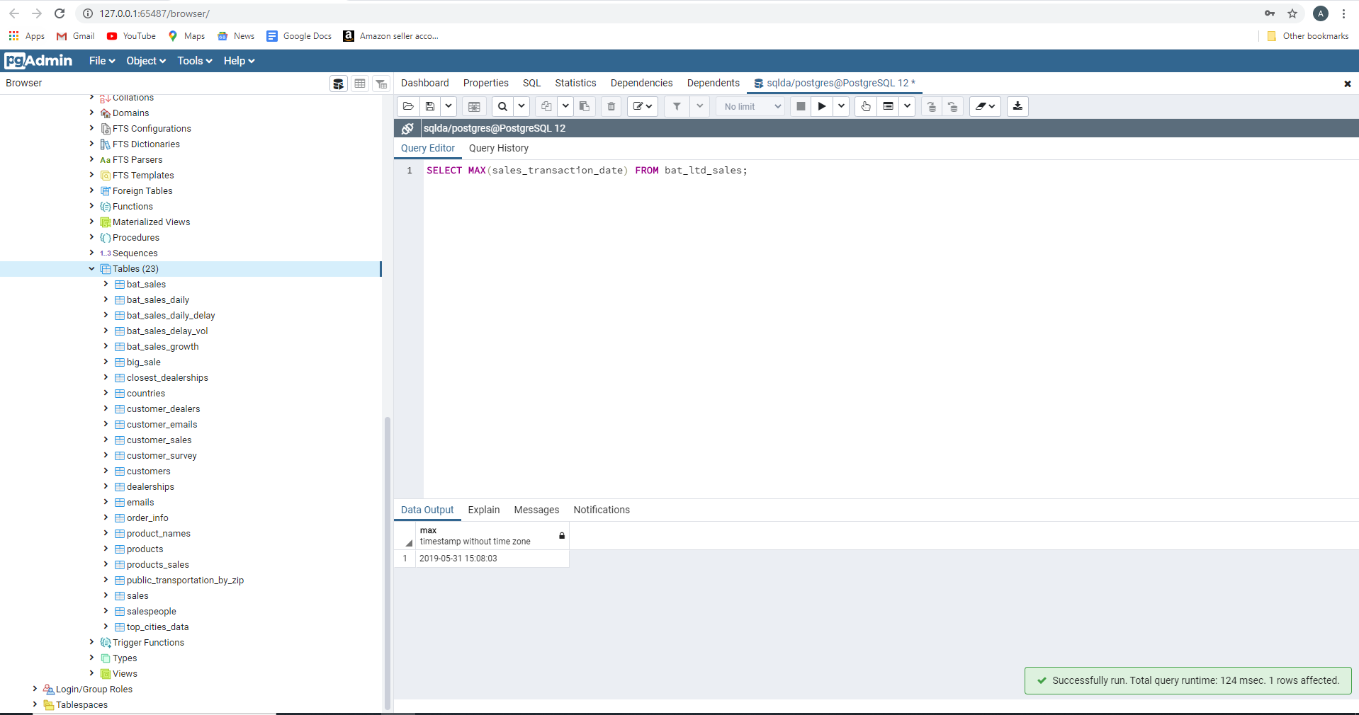

Table ‘bat_ltd_sales_count' is created



The records of the above table

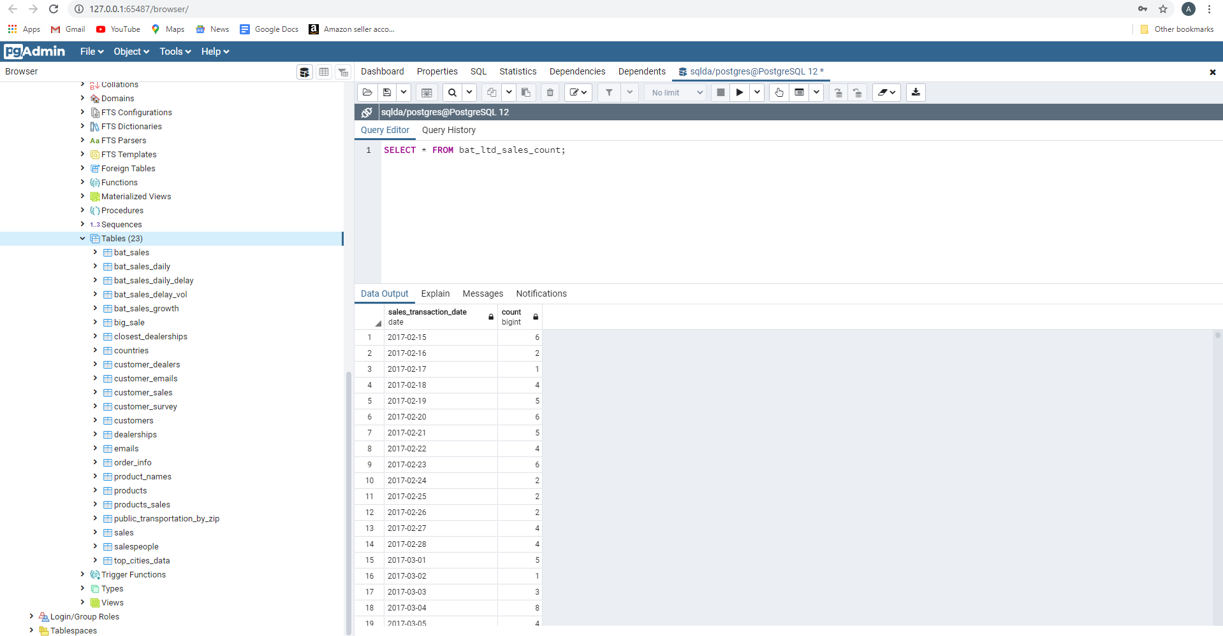

Computed the cumulative sales of bat_ltd_sales_count

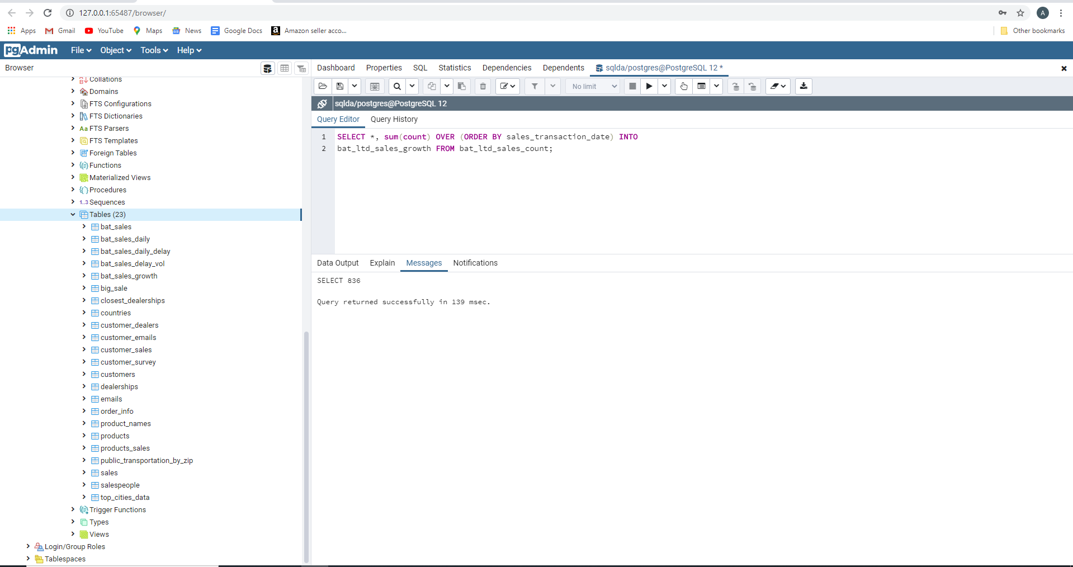

The first 22 rows of bat_ltd_sales_count after computing the cumulation

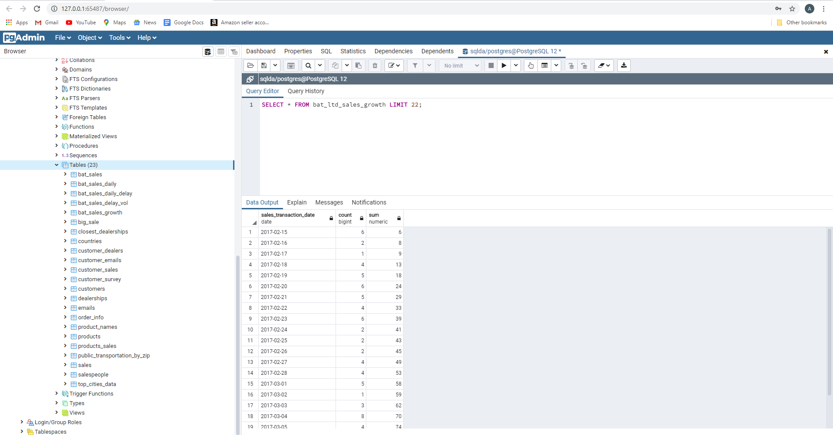

The first 22 records of bat_sales_growth

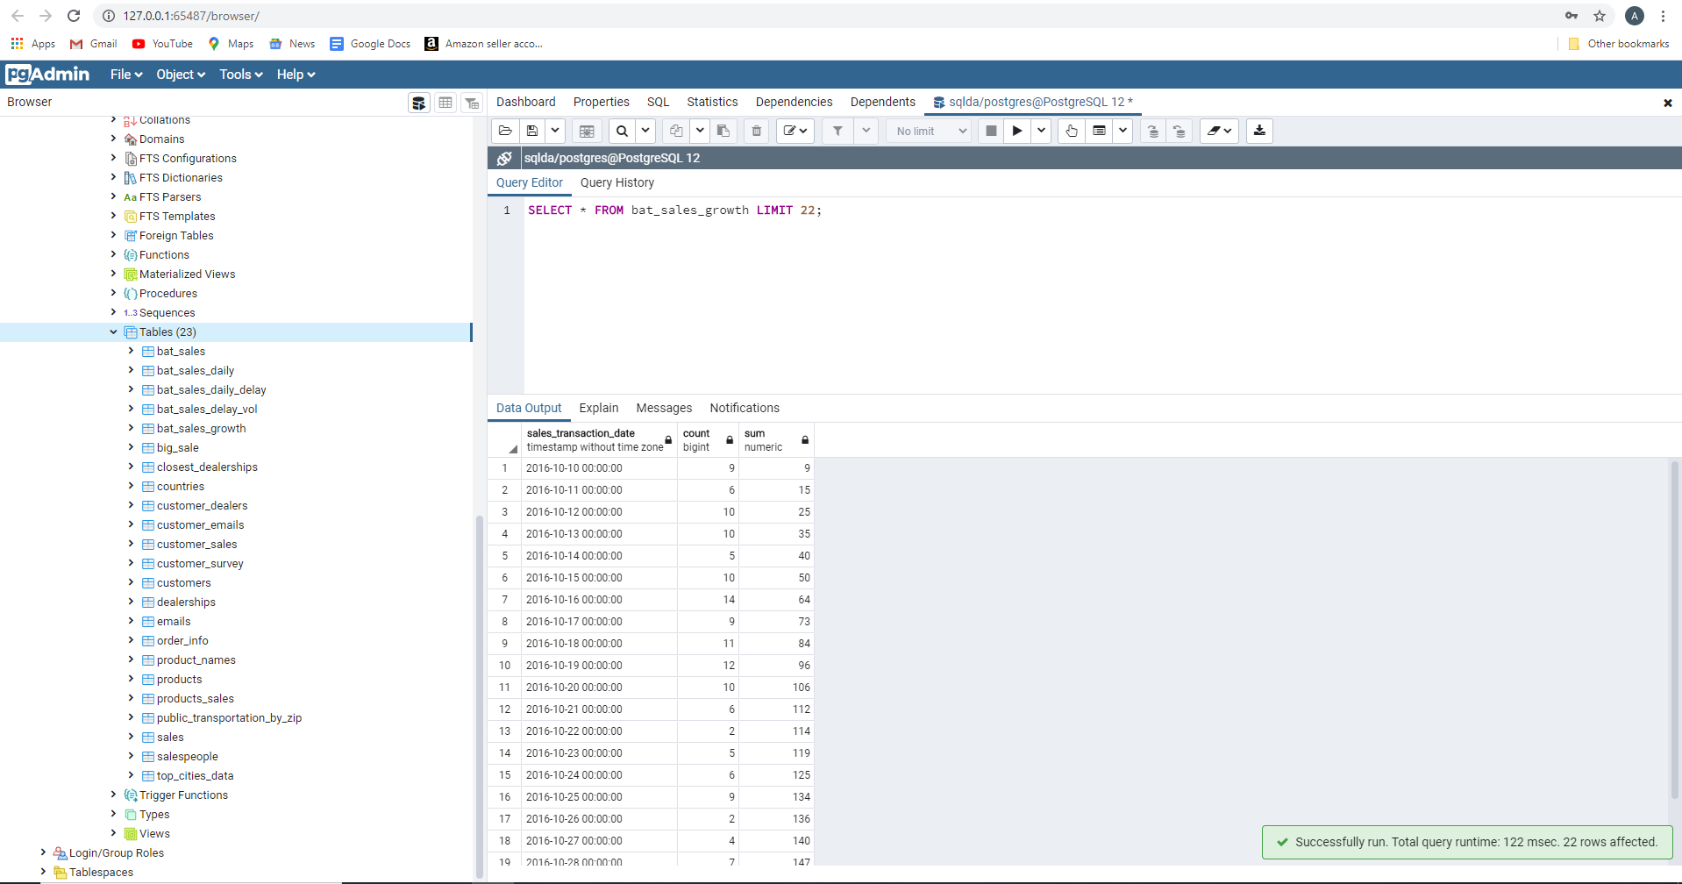

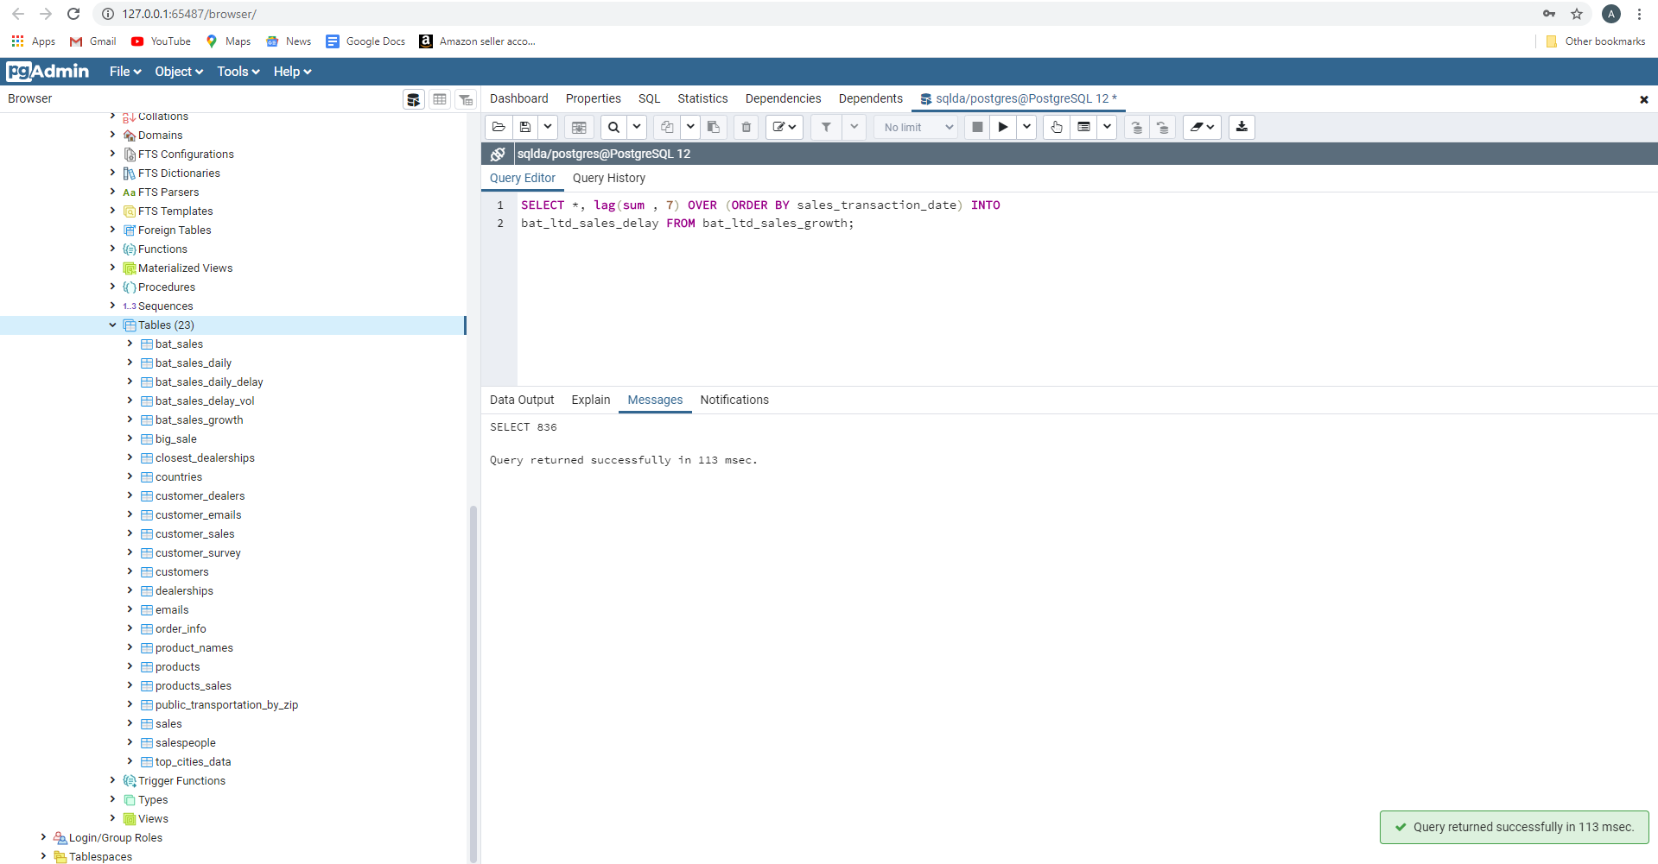

Sales growth compared as a percentage same as activity 18

